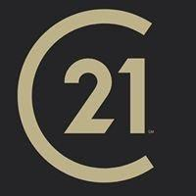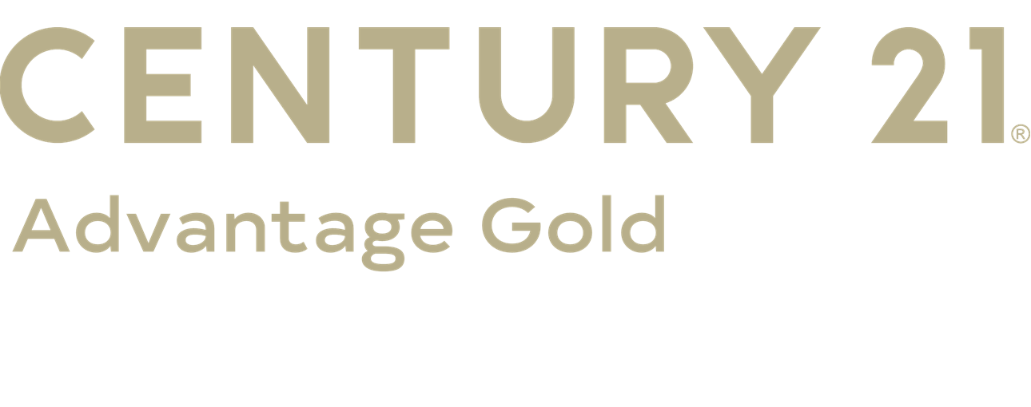

33 Language Skills APRIL 2022

Kira Shcherbakova, B Russian
Bogdan Dembitsky, S Ukrainian, Russian
Jacqueline Talpa, N Czech, Slovak
Sonny Malesevic, S Serbo-Croatian, Russian, Hebrew
Mitch Nikic, CG Serbian, Croatian, Yugoslavian
Panjola Koco, Aaron Mata, S Albanian
Maged ElSayed, So Ph Arabic
Monica Sutherland, Y-N & CH Portuguese, German, Spanish, French
Gabriella Procaccino, S Italian

Djmala Roy, N; Joshua Pope, S Creole
Joceline Bien-Aime, N French-Creole
Evette Ruiz, CG Spanish
Elsie Centeno, Kathy Robles, N Spanish
Hernan Font, N Spanish
Candy Martinez, N & CH Spanish
Amanda Aviles, CH Spanish

TJ Kolawole, B Yoruba, Hausa
Abin Babu, B Malayalam
Patience Momah, B Twi (Ghana District)
Kash Khan, Max Chowdhury, CG Bengali, Hindi, Urdu
Fazal Rehman, B Hindi, Urdu
Hetal Shah, Y-N Hindi, Gujarati

Emily Wang, So Ph Mandarin
Chris Wu, So Ph Mandarin, Cantonese, Fuzhouness
Monica Moc, S Vietnamese, Cantonese
Phong Lam, So Ph Vietnamese, Chiu Chow, Cantonese,
Mandarin
Winnie Ngo, S Vietnamese, Cantonese, Mandarin, Cambodian
Desy Fnu, So Ph Indonesian
MaryJoy Garulacan, B Filipino
Priya Sundaram, Y-N Tamil, Singhalese

Office Key: B=Bensalem; CG=Castor Gardens; CH=Cherry Hill; C=Collegeville; EP=Elkins Park;N-Sq=Newtown Square; N=Northwood; S=Southampton; So Ph=South Phila; Y-N=Yardley-Newtown

